**LAB AUTOMATION**

# 

# GROUP MEMBERS

**“AASIM”**

**Student1414731**

**“SAIF ULLAH”**

**Student1414765**

**“MUHAMMAD ALIYAN”**

**Student1417911**

**“ADEEL HUSSAIN”**

**Student1417960**

# CURRICULUM

**7062**

# BATCH

**2209C1**

# FACULTY

**“MS. NEELAM MALIK”**

# CO-ORDINATOR

**“MS. MUNAZZAH”**

**LOGIN**

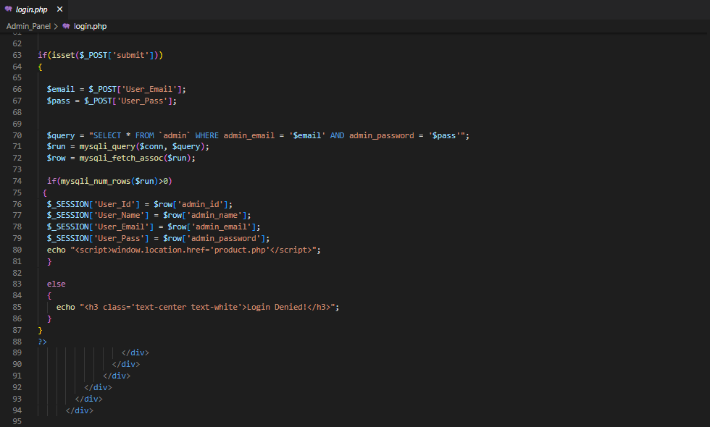

**ADD PRODUCTS**

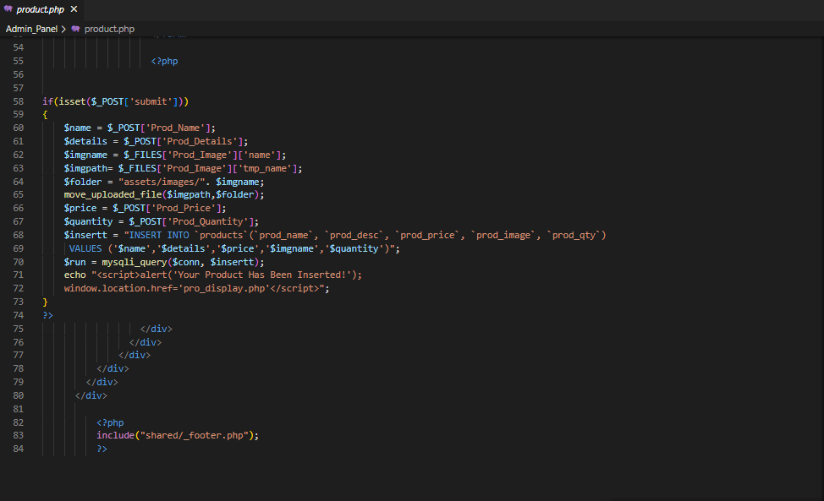

**DISPLAY PRODUCTS**

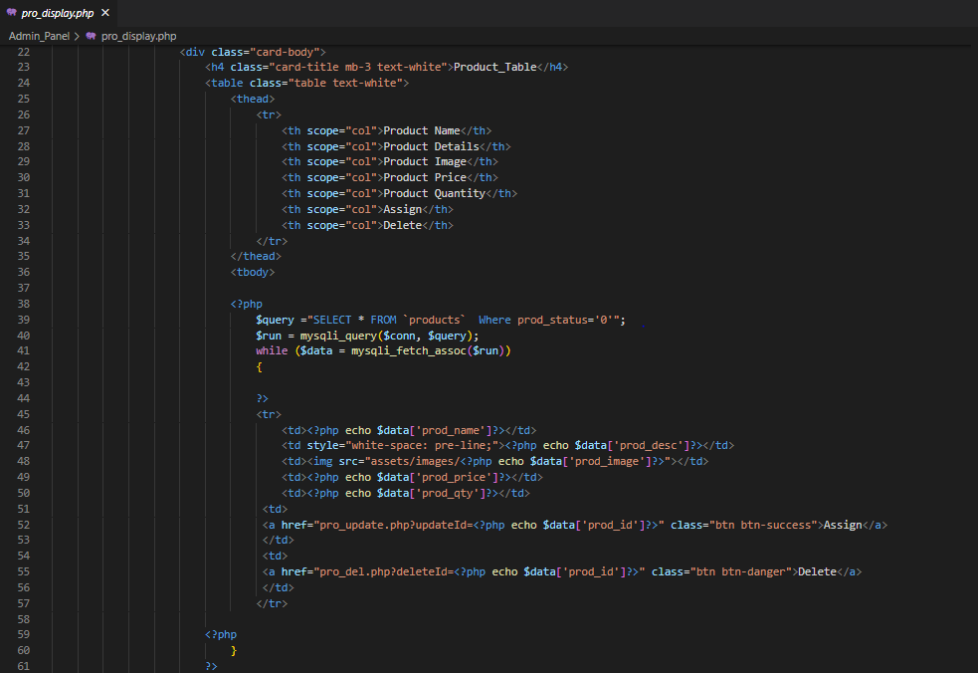

**PRODUCT ASSIGN**

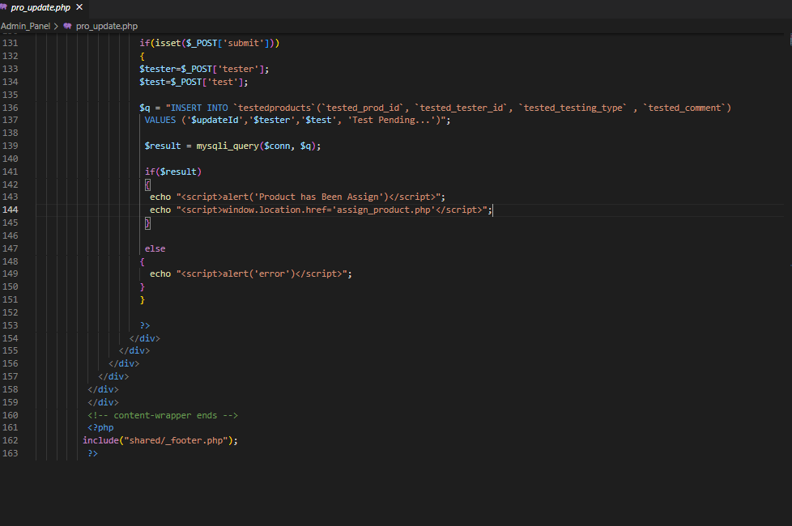

**DELETE**

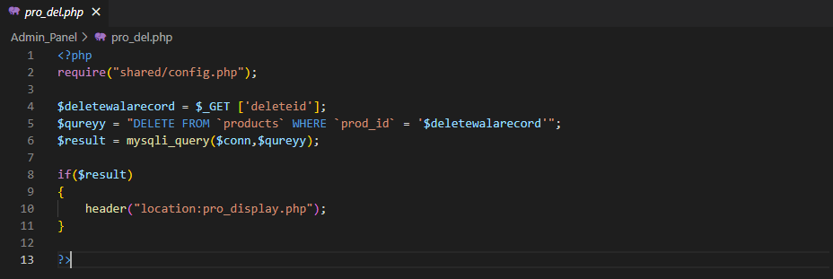

**TESTER DISPLAY**

